PROJECT DOCUMENTATION

Project Title: Fraud Detection in Online Transactions
Prepared by: Md Omair Subhan
Project Type: Data Analytics & Business Intelligence
Tools Used: Python & Power BI
Analysis Period: 2025

Introduction and Project Objectives
The Online Transaction Fraud Detection project analyzes transaction-level data to identify fraud patterns, financial exposure, behavioural indicators, and risk concentrations. The project combines Python exploratory analysis with an interactive Power BI dashboard so that analytical findings can be converted into a practical monitoring interface.
The dashboard and notebook are designed to help stakeholders understand how fraud varies across transaction value, risk, authentication behaviour, payment method, customer segment, device, city, location, international status, and time.
Project Objectives:
- Measure overall fraud volume and fraud rate.
- Identify high-risk transaction and behavioural patterns.
- Compare fraud across payment methods, customer segments and devices.
- Analyze city, location and international-transaction patterns.
- Study fraud by transaction hour, month and transaction type.
- Create an interactive Power BI dashboard for decision support.
- Translate analytical findings into practical fraud-monitoring recommendations.
Dataset Description:
Attribute | Description
Industry | Financial technology / digital payments
Domain | Online transaction fraud analytics
Analysis Type | Fraud detection, risk and behavioural analysis
Records | 19,697 transactions
Fields | 36 analytical fields
Tools | Python and Power BI

Data Fields
Column Name | Description
Transaction_ID | Unique transaction identifier
Customer_ID | Customer identifier
Transaction_DateTime | Transaction date and time
Amount | Transaction monetary value
Currency | Transaction currency
Payment_Method | Payment channel
Merchant_Category | Merchant business category
Transaction_Type | Transaction classification
City | Transaction/customer city
Country | Country associated with transaction
Device_Type | Device category
Browser | Browser used
Transactions_Last_24H | Recent transaction count
Distance_From_Home_KM | Distance from home
Failed_Login_Attempts | Failed authentication count
Account_Age_Years | Customer account age
Customer_Segment | Customer segment
Is_Fraud | Fraud target flag
Risk_Score | Overall risk score
Transaction_Status | Processing status
International_Transaction | Domestic/international indicator
Transaction_Hour | Hour of transaction
Weekend_Flag | Weekend indicator
Transaction_Amount_Band | Amount bucket
Velocity_Risk | Velocity risk category
Location_Risk | Location risk category
Login_Risk | Login risk category
Risk_Category | Overall risk category
Anomaly_Flag | Anomaly indicator
Card_Transaction_Flag | Card transaction indicator
Data_Quality_Flag | Data quality indicator
Amount_Quality | Amount quality classification

Data Cleaning
Data preparation was treated as an essential first stage before visualization and analysis. The project workflow included checking structure, data types, duplicates, missing values and inconsistent categorical values before loading the cleaned dataset for analysis.
Cleaning Steps:
- Imported the transaction dataset into the analysis workflow.
- Checked row and column counts and column names.
- Checked missing values and duplicate records.
- Reviewed Transaction_ID and Customer_ID consistency.
- Standardized categorical values such as customer segment.
- Converted date/time and numerical fields to appropriate data types.
- Created or validated analytical categories such as transaction amount bands and risk fields.
- Loaded the cleaned dataset for Power BI and Python analysis.

SQL Data Cleaning and Validation
SQL was used as a validation and analytical preparation layer after the initial cleaning workflow. The purpose was to verify record counts, inspect duplicates, validate categorical values, and support grouped fraud calculations before dashboarding.
SQL Activity | Purpose
Row-count validation | Confirm final transaction population
Duplicate checks | Identify repeated transaction records
NULL checks | Validate completeness of important fields
GROUP BY analysis | Compare fraud counts and rates by category
Aggregate calculations | Validate totals and averages used in Power BI
Conditional filtering | Investigate suspicious or high-risk records

Python Analysis Workflow
Python is the main exploratory-analysis tool in this project. The supplied notebook uses Pandas and NumPy for data handling, Matplotlib and Seaborn for visualization, and Scikit-learn components for a potential classification workflow.
- Load dataset into Pandas.
- Inspect shape, schema and descriptive statistics.
- Check missing values and duplicates.
- Analyze fraud/non-fraud class distribution.
- Compare transaction amounts.
- Calculate grouped fraud counts and fraud rates.
- Analyze risk, velocity, authentication, payment, customer, device and location dimensions.
- Analyze time-based patterns and correlations.
- Summarize findings for dashboard and recommendations.

Data Modelling and Dashboard Architecture
The Power BI report is organized around a central transaction-level table and dimension-style tables. The visible model includes Fact_Transactions, Dim_Date, Dim_Customer, Dim_Device, Dim_Payment and a DAX_Measures table.
Model Component | Role
Fact_Transactions | Central transaction-level data and numeric measures
Dim_Date | Year, month and date filtering
Dim_Customer | Customer and customer-segment analysis
Dim_Device | Device-level filtering and grouping
Dim_Payment | Payment-method analysis
DAX_Measures | Centralized reusable calculations

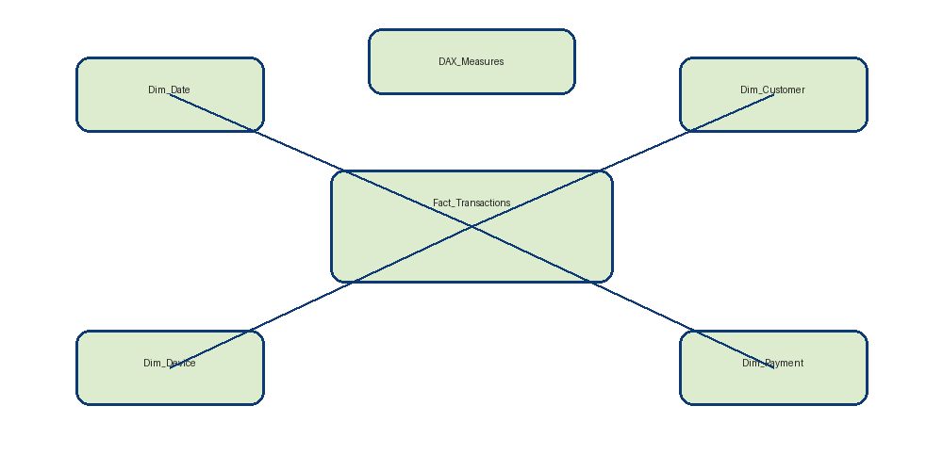
Figure: Simplified analytical model architecture.

DAX Measures
The Power BI report uses reusable measures for KPI cards and analytical visuals. The key measures are designed around transaction counts, monetary values, averages and fraud rates. Centralizing calculations makes the dashboard easier to maintain and keeps visuals consistent.
Measure | Purpose
Total Transactions | Count of transaction records
Total Transaction Amount | Total transaction value
Fraud Transactions | Count of Is_Fraud = 1
Fraud Rate | Fraud transactions divided by total transactions
Average Transaction Amount | Average transaction value
Fraud Amount | Total amount associated with fraud
Average Fraud Transaction Amount | Average amount for fraudulent transactions
Maximum Transaction Amount | Largest transaction value
Fraud Transactions per Customer | Fraud volume normalized by customer
Fraud Amount % | Fraud amount as a share of total amount
Payment Fraud Rate | Fraud rate by payment context
Typical DAX patterns used include SUM, COUNTROWS, AVERAGE, DIVIDE, CALCULATE and filter-context based calculations. The report also uses MAX/MIN-style aggregation where appropriate for transaction-value analysis.

Dashboard Page 1: Overview
Purpose: The Overview page provides a high-level fraud snapshot for stakeholders. It combines KPI cards with trend and category visuals so that the user can understand fraud volume, financial exposure and major transaction dimensions at a glance.
- KPI cards: total transactions, transaction amount, fraud transactions, fraud rate and average transaction amount.
- Monthly fraud transactions trend.
- Fraud transactions by payment method.
- Monthly total transaction amount.
- Fraud transactions by transaction amount band.
- Slicers for year, customer segment, payment method and risk category.
Key interpretation: The first page should answer “How large is the fraud problem right now?” before the user moves into deeper risk analysis.

Dashboard Page 2: Risk Analysis
Purpose: The Risk Analysis page focuses on financial exposure and risk segmentation.
- Fraud amount, average fraud transaction amount and maximum transaction amount KPIs.
- Fraud transactions per customer and fraud amount percentage.
- Risk-category fraud distribution.
- Risk-score / transaction relationship view.
- Merchant-category analysis.
- Fraud rate by velocity-risk category.
Key interpretation: This page moves from volume to severity. It helps identify where fraud creates the greatest financial exposure and which risk categories deserve closer investigation.

Dashboard Page 3: Transaction Behaviour
Purpose: The Transaction Behaviour page studies customer, time, city and amount-related behaviour.
- Fraud rate by customer segment.
- Fraud transactions by transaction hour.
- Fraud amount by transaction amount band.
- City-level fraud analysis.
- Risk Category × Payment Method matrix.
The page is useful for identifying combinations of conditions. A category with high fraud count is not automatically high-risk unless its underlying transaction volume is considered, so normalized fraud rate should be read alongside absolute counts.

Dashboard Page 4: Device & Payment Analysis
Purpose: This page brings together device, payment and authentication signals.
- Fraud amount by customer segment.
- Fraud transactions by device type.
- Fraud amount and payment fraud rate by payment method.
- Fraud transactions by account age.
- Fraud rate by failed login attempts.
The failed-login visual is particularly important because the Python analysis shows a strong increase in fraud rate as failed login attempts rise. This provides an operational signal that can be incorporated into risk rules.

Dashboard Page 5: Location Analysis
Purpose: The Location Analysis page combines geographic and authentication context with time-based exposure.
- Location-risk financial exposure.
- Domestic versus international fraud.
- Login-risk distribution.
- Monthly fraud amount.
- Transaction time-period analysis.
Location should be treated as contextual evidence rather than an automatic fraud label. International transactions can be legitimate, and high fraud counts in a city can reflect high transaction volume.

Dashboard Page 6: Insights
Purpose: The Insights page consolidates the project story into concise findings and recommendations. It should be the final communication layer for a non-technical stakeholder.
- Fraud is a minority event but creates meaningful financial exposure.
- Authentication behaviour is a useful risk signal.
- Payment method and transaction type show different fraud concentrations.
- Fraud varies across time, city, customer segment and device.
- Weak individual numerical correlations support a multi-signal fraud approach.

Fraud Distribution Analysis
The dataset contains 19,697 transactions. Of these, 653 are fraudulent and 19,044 are non-fraudulent. The resulting fraud rate is approximately 3.32%.
Metric | Value
Total transactions | 19,697
Fraud transactions | 653
Non-fraud transactions | 19,044
Fraud rate | 3.32%

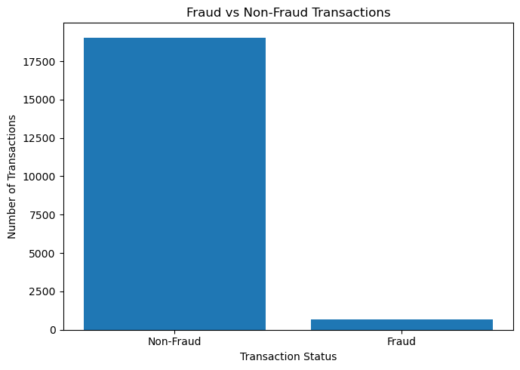
Figure: Fraud distribution visualization from Python.

Transaction Amount Analysis
Transaction value is an important fraud dimension. The notebook reports an average fraudulent transaction amount of approximately ₹7,911.53, compared with an overall average transaction amount of approximately ₹2,358.01. The median fraudulent amount is much closer to the non-fraud median, showing that extreme values influence the mean.
Metric | Fraud | Overall / Non-Fraud Context
Average amount | ₹7,911.53 | Overall average ≈ ₹2,358.01
Median amount | ₹1,087.44 | Non-fraud median ≈ ₹1,095.61
Maximum | ₹999,999.99 | ₹999,999.99
Minimum | ₹52.04 | Overall minimum -₹150

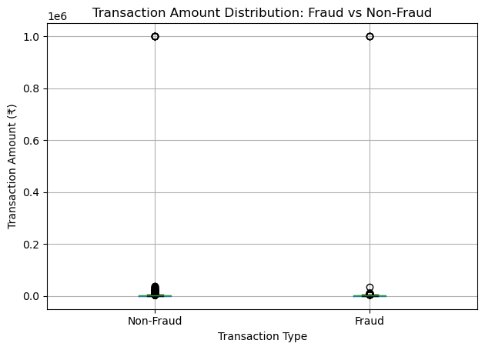
Figure: Transaction amount analysis.

Velocity Risk Analysis
Velocity risk represents transaction activity intensity. The project compares transaction volume, fraud volume and fraud rate across velocity-risk categories. This is useful for detecting rapid transaction patterns that may indicate account takeover, automation or payment abuse.

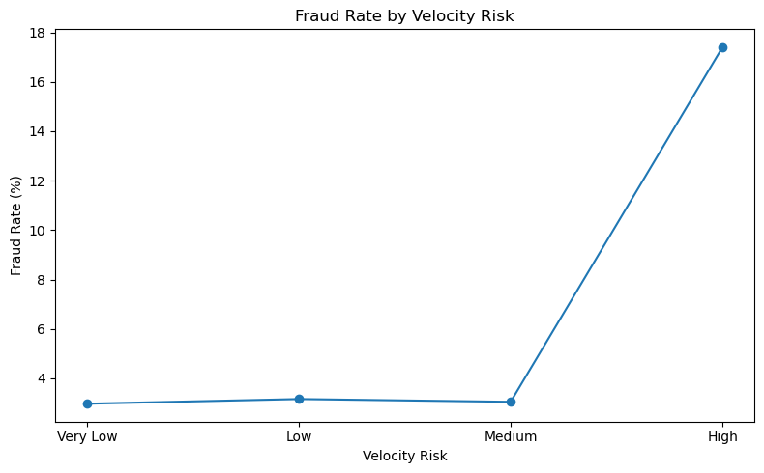
Figure: Fraud rate by velocity-risk category.

Failed Login Analysis
Failed authentication attempts are one of the strongest behavioural signals in the project. The final notebook findings report that fraud rate increases as failed login attempts rise, reaching 25% at five failed login attempts.

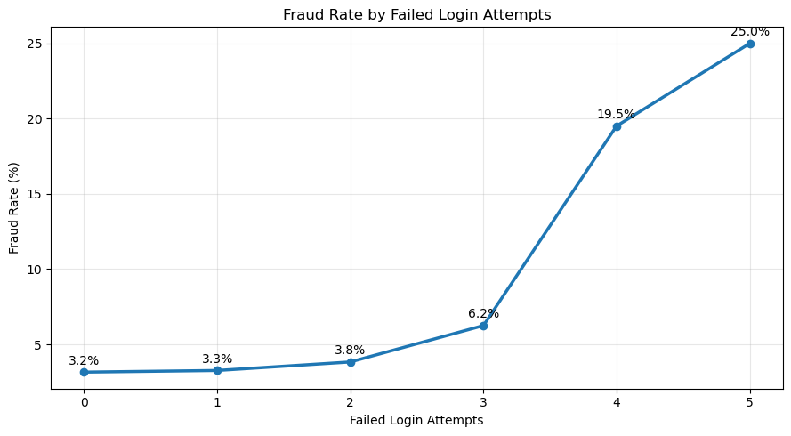
Figure: Fraud rate by failed login attempts.
Practical interpretation: repeated authentication failures followed by unusual transaction activity should receive elevated scrutiny or step-up authentication.

Payment Method Analysis
Payment methods show different levels of fraud activity. The project reports that UPI recorded the highest number of fraudulent transactions among the payment methods analyzed.

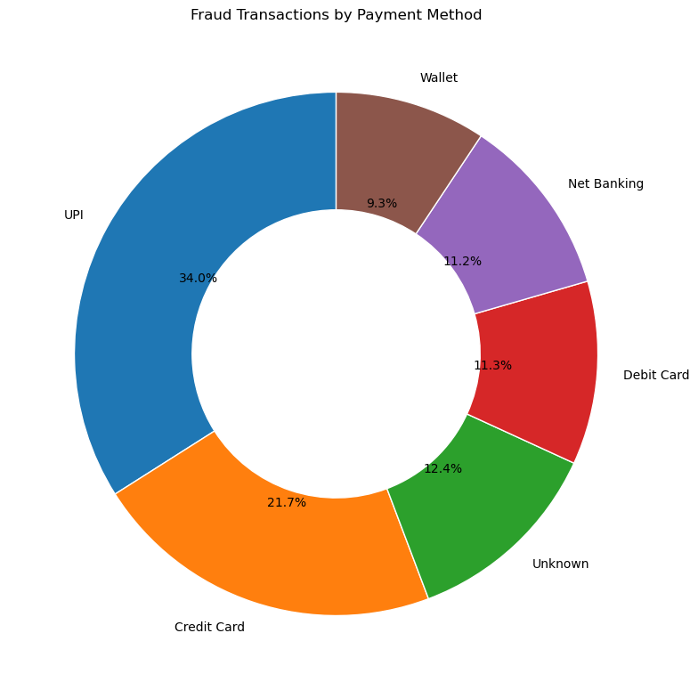
Figure: Fraud analysis by payment method.
Count and rate must be read together. A high-volume payment channel can naturally produce a high fraud count even if its fraud rate is not the highest.

Customer Segment Analysis
Customer segmentation provides context for fraud monitoring. Fraud rates and fraud amounts can differ by customer segment, making segmentation useful for prioritizing controls and reducing unnecessary friction for lower-risk customers.

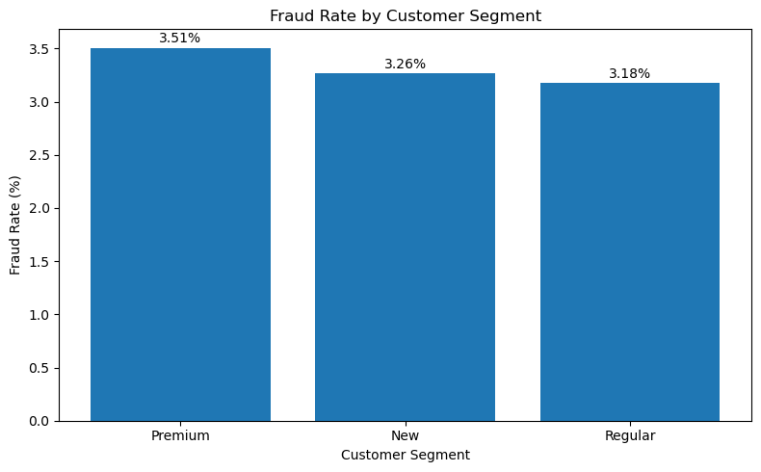
Figure: Fraud rate by customer segment.

Device Analysis
Device type is a behavioural signal. The project compares fraud transactions across device categories. A device-related signal becomes more valuable when combined with failed logins, location risk, velocity and transaction value.

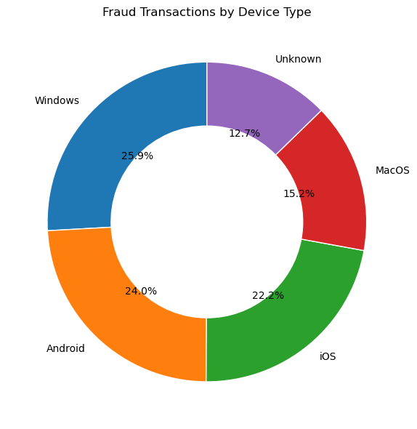
Figure: Fraud transactions by device type.

City and Geographic Analysis
The notebook creates a city-level summary containing total transactions, fraud transactions and fraud amount. The dashboard uses city analysis to help identify geographic concentrations of fraud.

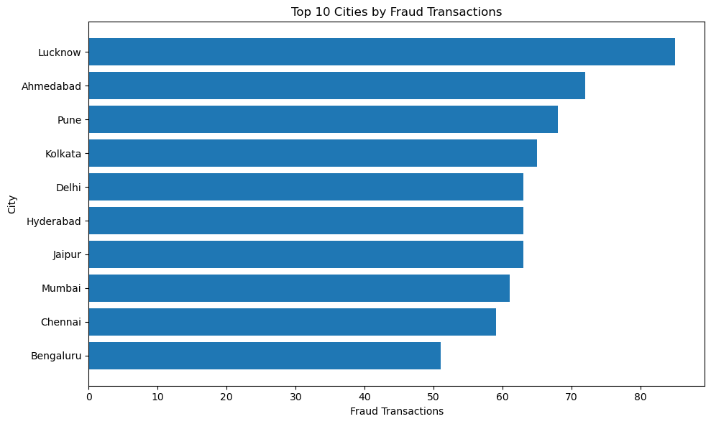
Figure: Top cities by fraud transactions.
A city with a high fraud count should not automatically be considered a high-risk city because transaction volume can be much higher there. Fraud rate is the better normalized companion metric.

International Transaction Analysis
The project compares domestic and international transactions and studies the interaction between international status and login risk.

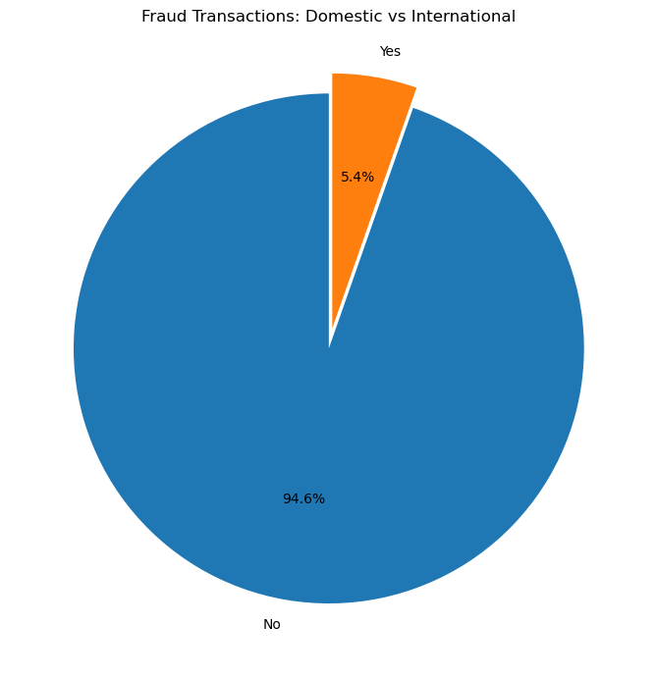
Figure: Fraud analysis by international transaction status.
International status is best treated as contextual evidence. It becomes more informative when paired with login, location, device and transaction-behaviour signals.

Time-Based Fraud Analysis
The notebook analyzes fraud by transaction hour and monthly fraud amount. Time-based monitoring helps detect changes in attack patterns and periods of elevated financial exposure.

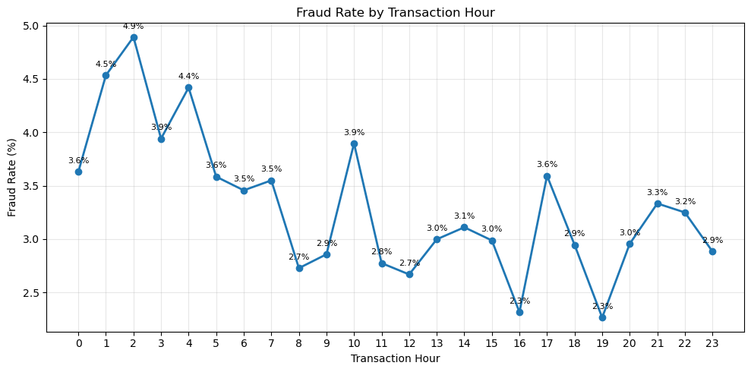
Figure: Fraud rate by transaction hour.

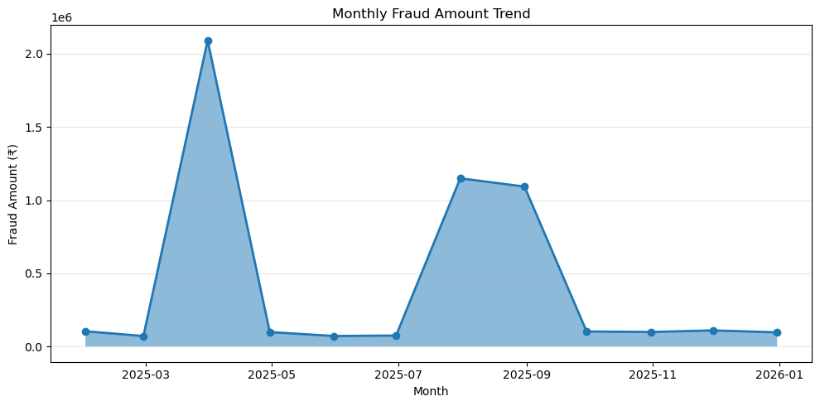
Figure: Monthly fraud amount trend.

Anomaly Analysis
Anomaly_Flag distinguishes transactions identified as anomalous from other records. The project compares anomaly categories with fraud counts and fraud rates.
Anomaly and fraud are related but different concepts. An unusual transaction is not necessarily fraudulent, and some fraudulent activity can resemble normal behaviour. This is why anomaly indicators should be combined with the fraud target and other risk signals.

Correlation Analysis
The notebook calculates correlations among Amount, Transactions_Last_24H, Distance_From_Home_KM, Failed_Login_Attempts, Account_Age_Years, Risk_Score, Transaction_Hour, Account_Age_Months and Is_Fraud.

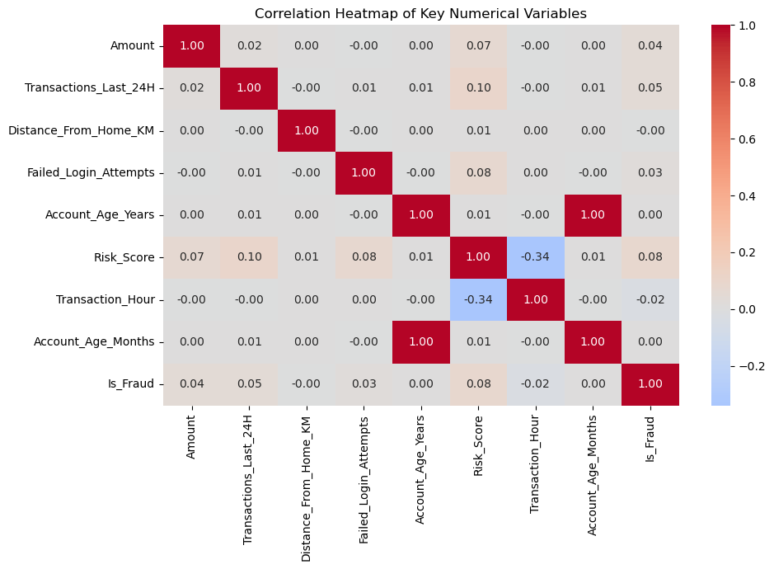
Figure: Correlation heatmap.
The project findings indicate that most individual numerical variables have weak correlations with fraud. This supports the conclusion that fraud detection is multi-factor rather than dependent on one numerical variable.

Key Business Findings
Finding | Interpretation
3.32% fraud rate | Fraud is a minority event but operationally important
₹5.17M fraud amount | Fraud carries meaningful financial exposure
Higher average fraud amount | Financial impact can be concentrated in fewer cases
Failed logins | Strong behavioural risk signal
UPI highest fraud count | Payment channel should be monitored with both count and rate
Purchase highest fraud share | Transaction type provides useful context
Weak individual correlations | Combined signals are more appropriate than one-variable rules

Business Recommendations
- Create a combined risk score using amount, risk score, velocity, failed logins, location risk, login risk and device context.
- Use step-up authentication when several high-risk signals occur together.
- Monitor failed login attempts as an early-warning indicator.
- Track payment methods using both fraud count and fraud rate.
- Tune thresholds by transaction type and customer segment.
- Use city and location trends for investigation prioritization, not automatic blocking.
- Refresh the Power BI dashboard regularly to detect changes in fraud patterns.
- For future ML work, evaluate precision, recall, F1-score, ROC-AUC and business cost of false positives/false negatives.

Design Standards and Colour Palette
Role | Colour / Style | Usage
Theme Colour | #0d3a74 | Page headers / major dashboard elements
White | #FFFFFF | Cards and clean visual background
Blue | #1A73E8 | Primary analytical visuals
Accent Orange | #DD7030 | Documentation section headings
Light Green | #DDECCF | Documentation tables
Typography | Aptos / Segoe UI style | Readable business-report presentation
Layout principles: use KPI cards first, place the primary analytical chart below or beside them, keep slicers consistent, avoid unnecessary chart repetition, and use concise titles such as “Fraud Rate by Risk Category”.

Technical Notes and Known Issues
Important technical considerations identified during the project include data-type validation, categorical consistency, duplicate checking, numeric outliers and class imbalance.
Issue / Consideration | Recommended Handling
Class imbalance | Use fraud-aware evaluation metrics
Extreme Amount values | Inspect outliers and use median alongside mean
Categorical inconsistencies | Standardize values before grouping
High-cardinality IDs | Use IDs for relationships, not unnecessary visuals
Dashboard performance | Remove unused columns and centralize measures
Many-to-many relationships | Ensure dimension keys are unique
Correlation interpretation | Do not treat correlation as causation

Glossary
Term | Definition
Fraud Rate | Fraud transactions divided by total transactions
Risk Score | Numerical indicator representing transaction risk
Velocity Risk | Risk classification based on transaction frequency/intensity
Location Risk | Risk classification associated with location context
Login Risk | Risk classification based on authentication behaviour
Anomaly Flag | Indicator that a transaction is unusual according to the dataset logic
KPI | Key Performance Indicator
DAX | Data Analysis Expressions used in Power BI
Fact Table | Central transaction-level table
Dimension Table | Descriptive table used for filtering/grouping
Slicer | Interactive Power BI filter control
EDA | Exploratory Data Analysis

Conclusion
The Online Transaction Fraud Detection project successfully combines Python exploratory analysis with Power BI dashboarding to transform transaction-level records into actionable fraud intelligence. The dataset contains 19,697 transactions and 653 fraud cases, producing an overall fraud rate of approximately 3.32%.
The analysis demonstrates that fraud should be investigated as a multi-dimensional problem. Transaction value, failed login attempts, velocity, payment method, customer segment, device, location, international status and time can each contribute useful context, but no single variable should be treated as a complete fraud rule.
The Power BI dashboard provides an executive overview followed by dedicated risk, transaction behaviour, device/payment and location pages, ending with a consolidated insights layer. The project therefore demonstrates practical skills in data cleaning, SQL validation, Python EDA, Power BI modelling, DAX measures, visualization and business interpretation.

